INTRODUCTION
The energy sector is moving fast toward digitization, linking with distributed energy
resources, electric vehicle charging and meter level consumption tracking with legacy grid operations. The digitalisation is accompanied by an increase in the data variety, volume and velocity, as well as an increase in the importance of data protection, system resilience, and adherence to regulations (Bayındır et al., 2025). An example of these pressures is MetroEnergy Solutions (MES), whose need is to seamlessly integrate data from smart meters, EV charging stations, energy management, solar monitoring systems, substation IoT sensors, customer billing systems, and maintenance systems, whilst simultaneously having to deal with disparate regional platforms, manual data ingestion, inconsistent data formats from disparate energy management vendors, and limited visibility about pipeline performance.
This report has been presented on the background of designing a sustainable and flexible solution that is also compliant with a cloud based big data solution for MES. It is organised around the five questions defined by the assignment brief and in so doing, addresses the four learning outcomes, explaining the development and problems of cloud computing and big data analysis (LO1), critically evaluating cloud computing platforms and the applied approach to data processing (LO2), designing and implementing a solution appropriate to the scenario (LO3), identifying and examining opportunities for innovation and solution development (LO4). Throughout, illustrative, synthetic data and simplified diagrams have been used, just as the permission granted for the assignment to use hypothetical data to demonstrate conceptual understanding. The report does not make any determinate statements about any leading commercial cloud provider rather about architectural patterns and service models based on their technical merits, to give MES room for negotiation and long-term flexibility.

1. TECHNICAL, ETHICAL AND REGULATORY REQUIREMENTS
1.1 Data Acquisition Requirements
The 6 main data sources of MES have a wide range of cadences, structure and criticality. From a granularity standpoint, there should be near real time (millisecond, second) readings (telemetry data) generated at smart meters and substation IoT sensors and monitored for grid stability, EV charging stations and solar inverters will take moderate readings, either on a session basis or according to irradiance data, and billing and maintenance management systems will typically require batch data on a daily or weekly basis. Big data later extended to encompass veracity, volume, velocity and variety. Data acquisition from MES will all follow these four tenets. Therefore, acquisition pipelines need to be able to adapt and support events for time critical telemetry and schedules and batch extraction for administrative systems, like described in the layered IoT architecture in Gubbi et al. (2013) in which the perception layer consists of a set of sensors and meters, and the transportation of data reliably from the perception layer to the other layers is handled by a network layer only.
1.2 Storage Requirements
Data found in MES could vary from a system with well defined data schema such as billing data, to a system with semi structured data, such as payloads from sensors, to unstructured data like maintenance logs, and there's no reason to store all of them in a single relational store economically. They should be schema flexible (with raw data streaming it), strongly consistent (for regulation/billing information), long retention (some historical information can be stored for timeseries analytics) and tiered (some historical information is infrequently accessed, with a desire to move it to lower cost storage tiers). There are some regulatory requirements that are also currently impacting the non functional characteristics of MES, Encryption at rest, Immutability of raw records for audit purposes, and Fine grained access control.

1.3 Processing Requirements
MES requires two complementary regimes. Power outages can impact safety or the quality of service, only if stream processing is being used, for example, if communicating voltage anomalies at a substation and for EV charger failure notifications. This paradigm
of computation is suitable for an application where correctness and completeness are
more important such as computing and creating relevant trends in bills,
retraining models, etc., in a batch processing application. This goal can be achieved by a two in one, a speed layer using the classical lambda approach, keeping the speed of a substitution of the view, but a batch layer keeping a complete historical of data for periodically rebuilding the view, and a more recent kappa style attempt to unifying both approaches in a framework of stream processing replayed over its stored events. But if one considers the “dirty” (mixed real time/batch) nature of MES's estate and homegrown maturity when it comes to Streaming, then a pragmatic hybrid (as opposed to pure/batch clean state rebuild of legacy batch billing systems) is more prudent to consider when looking at the transition target goal.
1.4 Analytical Requirements
The need exists for descriptive analytics (as consumption dashboards), diagnostic analytics (root cause analysis for voltage excursions), Predictive analytics (short term consumption forecasting, peak load forecasting this was also demonstrated during the proof of concept in Section 4) as well as predictive maintenance of grid assets, and prescriptive analytics (optimized rescheduling of charging, demand response recommendations). One of the well established aspects of the smart grid literature is the idea of demand side forecasting and, more specifically, peer reviewed demand side response, shifting and reducing the peak demand, when very detailed demand information is available (Siano, 2014), which gives arguments for the business case of a forecasting oriented approach outlined later in this report.
1.5 Challenges of Big Data for MES
The number of smart meters and Internet of Things (IoT) sensors is growing and so is the cost of ingestion and storage, also latency and bandwidth bottleneck in the cloud when centrally processed particular when it comes to timeliness and accuracy of Grid telemetry (Bayındır et al., 2025).
Variability and interoperability, There is no common data model for meter, inverter and charger vendors, so vendor specific transformation logic proliferates downstream.
Veracity and Data Quality, The distributed field devices are not always connected,
clock drift can occur, and sensor failure is common, some care should be taken in
trusting the data to ensure it is used correctly in billing or safety critical decisions.
Fragmentation and visibility, MES has a poor view of the status of the health of the pipelines, making it difficult for MES to see visibility of the silent data loss or that data simply isn't being delivered.
1.6 Technical Considerations
The largest one still is Interoperability and technically MES need to connect with the legacy Grid Management systems (often proprietary, SCADA based) and the modern IoT Tooling / Cloud native tooling. It's an invitation to use open data formats and published schemas at ALL interface points and a schema registry to enforce a “contract” discipline (as opposed to allowing it to be an ad hoc affair, a decision by individual vendors for each device).
1.7 Ethical Considerations
The proportionality issues are particularly pertinent to the finer grained patterns of behaviours which come with smart meter data that the processing is lawful doesn't mean that it is proportional. This should include ‘data minimisation’ (only collecting what is strictly necessary for the purpose), transparency when collecting data and informing customers on how it will be used and ensuring there is no algorithmic bias that impacts customers systematically in a particular fashion, such as customers forced to use lots of electricity for health reasons. The concept of granular energy metering in smart metering has been a very important aspect to study building consumer trust is a precondition to their social acceptance of granular energy monitoring, this means that transparency and trust are core to the communication strategy, and consent mechanisms.
1.8 Regulatory Considerations
MES operates in the UK and also in continental Europe whilst MES service may be provided in both continents MES itself is bound to the following Data protection legislation, In the UK, the GDPR (for service provision within the UK) as well as the Data Protection Act 2018, In continental Europe, the EU GDPR (Regulation (EU) 2016/679) (for service provision within continental Europe). Both regulate impose a fine of up to 4% of the global turnover or of maximum 20 million euros in the case of material violations,
impose a requirement of lawful grounds on the processing of the personal data of energy
consumers and give them access rights, the right to data portability and the right
to data erasure. (Frost & Sullivan, 2020). In practice, this will mean that MES will appoint a Data Protection Officer, keep track of MES's data processing activities and will ensure ‘privacy by design' which has been designed as ‘privacy first' as a core MES principle. However, MES are also required to comply with the UK Network and Information Systems (NIS) Regulations that relate to the security of essential services and the Ofgem license conditions relating to smart metering and information data access in the energy sector. All negate the fact that Compliance and regulatory should not be an overlay point of application control, but clearly this must be effective from the design stage through acquisition through storage and processing.

2. EVALUATION OF CLOUD COMPUTING MODELS, ARCHITECTURES AND PROCESSING APPROACHES
2.1 Cloud Deployment Models
There are four deployment models to choose from public, private, hybrid and multi cloud. The data residency programmatic aspect related to MES cross border (UK/EU) business is closely linked to its data centric business model, consumption centric mode, but is also faced with the most immediate path to elasticity and managed services, offered by a pure public cloud. The pure private cloud estate (on premise or hosted) provides the greatest control but has the high capital cost and slow scale attributes that MES is trying to eliminate, and
doesn't do much to fix the interoperability problem caused by the various regions' platforms. A hybrid model is ideal keeping the substation data with latency sensitivity in the private/edge computing system while feeding the rest of the data into public cloud for analytics, forecasting and offloading, which would suit the needs of MES, given its mix of both real time and batch operations, as well as mixed jurisdictions. A multi cloud approach (mixing multiple clouds and intentionally not being dependent on a single provider) complements MES negotiating position and continuity of service in a secure manner, but at a tremendous complexity and cost, and requires careful management of integration (open standards and abstraction layer).
2.2 Cloud Service Models
The NIST definition of cloud computing used by Mell and Grance (2011) differentiates the infrastructure as a Service (IaaS), Platform as a Service (PaaS) and Software as a Service (SaaS) by what part of the stack is managed by the provider versus what part is retained by the customer. With IaaS, MES is provided maximum control of operating systems and networking, which is beneficial for edge compute applications located next to the substation, but leaves it to the MES engineers to perform patching, scaling and resiliency. The ability to access custom pipeline logic but not have to worry about the undifferentiated operational overhead of a managed database service, streaming and orchestration services make PaaS an excellent fit for MES's core data platform. This is only applicable to e.g. a billing/ticketing application, but not for applications such as SaaS where MES doesn't have to differentiate in the underlying technology. The critical evaluation concludes that a single model “one size fits all” MES implementation is not likely to achieve an operational efficiency/command control balance, a blended approach of IaaS/edge for latency sensitive telemetry, a core data platform in a PaaS form factor and commodity SaaS back office functions is best.
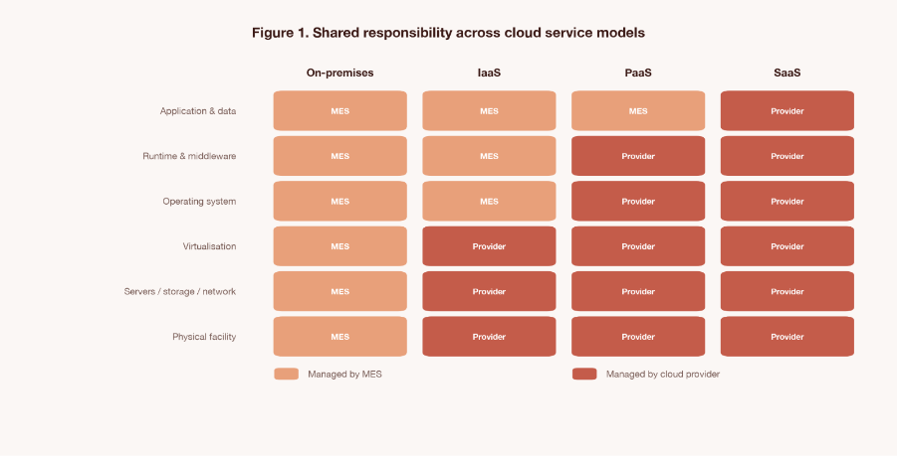Figure 1. Shared responsibility split across cloud service models, illustrating why a blended IaaS/PaaS approach suits MES's mixed latency critical and analytical workloads.
2.3 Processing Approaches, Batch, Stream, Lambda and Kappa
In Section 1.3 it was also determined that MES must be "stream" and "batch". Architecturally the same can be accomplished in a lambda system (e.g. keep a list of the speed layer and batch layer and perform batch equivalent recomputation on a separate batch layer) or a kappa system (e.g. maintain a single replaying streaming engine that can also replay history to a batch engine to do batch equivalent recomputation). A purist kappa rebuild is good in theory, but would also have to be a lowrisk change for MES as they have a manual and divided environment and it would also have to be done immediately which isn't the reality in the face of the manual environment they have. If there is a loss of both the two maintenance costs of the “hard” lambda architecture, but a batch API and a streaming API can still be obtained from a single little optimized data set, then that's a very good tradeoff.
2.4 Data Lake, Data Warehouse and Lakehouse Architectures
Because MES's set of billing records (structured) and sensor and maintenance information (semi structured and/or unstructured) is diverse a "pure" warehouse approach is not applicable, while schema on write and good data warehouses manage well with governed data reporting, they are not as easy to use economically raw, massive telemetry information coming from MES IoT sensors and the ability to maintain them (IBM, 2026). The ingestion and cost problem is solved by having cheap schema on read object storage in a pure data lake, but if the data lake doesn't have enough discipline with it to control or reliably query, it turns into a ‘data swamp' that is hard to manage. This tension has become quite apparent, and the outcome of that pattern, the lakehouse pattern, is a single copy of data that makes it possible to serve a range of workloads, including business intelligence, machine learning and streaming workloads, with both high availability and flexibility that a data lake offers, and transactions, schema enforcement and catalogue features that a warehouse offers (Databricks, 2026). One way MES curates the underlying information from sources like the smart meter telemetry, EV session log, weather feeds, etc., for subsequent reporting to regulators and predictive analytics, is by using a lakehouse based curated zone, which is described in detail below, without the need to maintain the two parallel platforms which are typical challenges with MES addressing fragmentation.
2.5 Justified Recommendation
Taking all of the above into account, the following hybrid cloud architecture is recommended, a cloud based lake house service oriented around the storage of data and combining IaaS/PaaS service model rather than just relying on a specific provider's cloud stack, This is an intentional vendor neutral approach, capable of being realized using any vendor (or set of vendors) that supports the open storage formats and fundamental portability to containers, and provides standard streaming protocols as well, tackling the fragmentation and interoperability problem point of the case studies.
3. DESIGNING A BIG DATA ARCHITECTURE FOR METROENERGY SOLUTIONS
3.1 Architectural Overview
The proposed structure is as mentioned in Figure 2. Interacting with source systems before immutable raw zone is followed by moving through processing engines to a curated, open format lakehouse is a dual ingestion tier (stream and batch). The curated zone is used to feed operational dashboards, customer facing billing systems and legacy grid management and third party vendor systems with data from the warehouse/marts layer (governed data), analytics and forecasting workbench and API/event layer (interoperability). It is a horizontally secure and governance layer, it has a horizontally orchestration, horizontally observability, horizontally resilient layer and all the elements of the platform are clearly within a regulatory/compliance perimeter

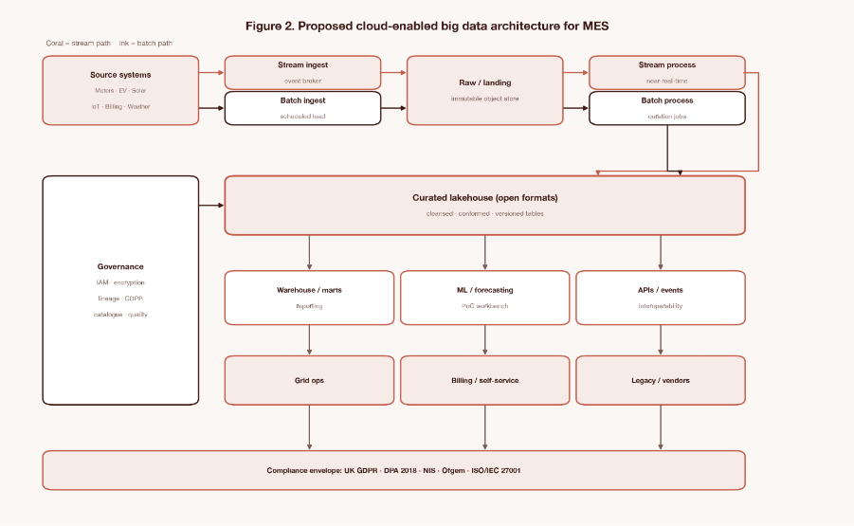
Figure 2. Proposed cloud enabled big data architecture for MetroEnergy Solutions.
3.2 End to End Data Flow
Figure 3 shows a specific use case scenario of data flowing from field devices and enterprise systems, normalising, then passing through the zones of the lake house for stream analytics, fault/anomaly alerting, batch analytics and machine learning, demand forecasting, load profiling, reporting/billing extracts, to the grid operations dashboards and customer
application/reporting output for regulatory reporting. The feedback loop (shown in red) is continuous and carries the other pipeline health and data quality signals right back to the pipeline ingestion and normalisation stages, directly addressing MES's limitation of "limited visibility into pipeline performance".

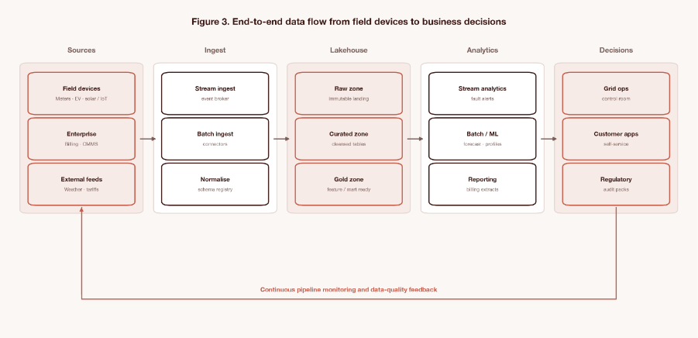
Figure 3. End to end data flow from field devices to business decisions, including a pipeline monitoring feedback loop.
3.3 Component Rationale
a. Ingestion tier
Changes to a device do not require a renegotiation of integration with the device as producers and consumers subscribe to the publish/subscribe event broker, which separates the time sensitive producers (for example, meters, chargers, sensors) from producers and consumers, it also overcomes the ‘inconsistent data formats across vendors’ constraint by normalising data prior to ingestion to the event broker instead of at the device level. Billing and maintenance extracts will be pushed now, instead of reading them manually, with automatic retry and logs, in the scheduled job.
b. Raw zone and curated zone.
Encryption is used to protect the data in the raw zone, and it simply contains the data as received, and cannot be changed, it can offer the ability to audit and reprocess if the logic used to transform the data changes. In the curated lake house zone, data undergoes data quality rules, is deduplicated, conformed to a common information model, stored in a open table format, and then, is available for ACID transactions on object storage, thereby supplementing the ingestion flexibility and trustworthy, query ready analytics data requirements outlined in Section 2.4 for MES.
c. Processing engines
The same tables are used for the stream and batch processing engines, with the former used for sub minute fault detection and the latter for nightly billing reconciliation and periodicals model re training, like the hybrid recommendation from Section 2.3.
d. Serving and consumption
A warehouse/marts layer provides basic support for reporting and auditing for reporting to regulators, an analytics/ML workbench is home to forecasting models, including proof of concept presented in Section 4, and an API/event layer will enable basic support for interoperability with standard grid management and third party vendor systems, allowing a wholesale replacement of operating legacy systems by MES without requiring MES to be replaced.

3.4 Technical, Security, Compliance and Performance Responsibilities
In terms of design, that's technically a scalable and interoperable design because the design decouples compute from storage, and all boundaries are open by using formats that are open, and a schema registry could make any Schema drift downstream by the vendor visible and manageable. It is secured by end to end encryption from start to finish, in transit, in storage, role based access control and attribute based access control (which is scoped by the sensitivity of the data for example a limited number of people have access to raw personally identifiable consumption data, whereas a much more extended audience has access to aggregated regional data), and centralised key management. A data catalogue and data lineage layer is built in to help answer the ‘where does this personal data live and where has it flowed' question that is required when complying with GDPR] requests for information on personal data, erasure and GDPR requirements for minimum and maximum retention periods. When deployed across various regions with asynchronous replication and automated backup including tested disaster recovery runbooks are enabled, the next constraint in the case study, ‘limited visibility into pipeline performance', is overcome by continuous monitoring of the pipeline and providing the metrics in operational dashboards like latency, throughput, data quality etc.
3.5 Controlling Costs by Design
Separation of storage and compute will enable MES to automatically shift cold historical data to lower cost storage tiers, scale ingestion and processing to the volume of telemetry, without need for provisioning for peak storage. In addition, they are helping to consolidate for now, several regional, disjointed platforms into a single, governed lake house and eliminating redundant licensing, storage, integration maintenance costs and even directly working toward the cost control objective of the brief.

4. PROOF OF CONCEPT, SHORT-TERM DEMAND FORECASTING
4.1 Objective and Scope
This prototype illustrates one aspect of the proposed architecture, There is a short-term (24-hour horizon) electricity demand forecasting job which is scheduled to be run on the curated zone of the lakehouse, as described in Section 3, batch analytics and machine learning workbench. Giving evidence for this one part (not the complete stack) is a way of showing this part of the assignment which requires a small scale demonstration with evidence of implementation.
4.2 Dataset and Methodology
A synthetic dataset of smart metered half hour data was then created, statistically designed to match the publicly available smart meter datasets available in the UK, such as the Low Carbon London smart meter trial, with the inclusion of statistically realistic morning and evening peaks, weekday/weekend variations, temperature sensitivity and sensor anomalies. This report uses a synthetic dataset since the implementation environment set up in the sandbox does not have an Internet connection to download or bring in a one directly from the real world, EXCEPT in the case of the assignment brief where it is relevant to the scenario, in which case the building of the sequence described in this report is documented so that its properties can be judged and reproduced openly. Engineered inputs were those added to Calendar, such as the hour of day, day of week, weekend flag, etc., and lagged demand features are features that represent the transformation logic that can be applied within the curated (or 'gold') zone of the lakehouse, including the same time yesterday, same time last week, and a 48-period rolling mean. The Gradient Boosted Regression Trees model (scikit-learn) was trained from an 85/15 train/test split but there was no leakage of future information into the train set.
4.3 Implementation Summary
The structure is the same as an actual deployment (production batch job) with the difference that artefacts (evaluation charts and metrics) are outputted to be used as a dashboard for evaluating the system, instead of doing an actual deployment where they would be published to the serving layer for dashboard consumption. A summary of the modelling logic is presented below,
model = GradientBoostingRegressor(n_estimators=250, max_depth=3, learning_rate=0.05) features = ['hour','dow','is_weekend','temperature_c','lag_48','lag_336','roll_mean_48'] model.fit(X_train[features], y_train) predictions = model.predict(X_test[features])
4.4 Results
Table 1 summarises the results of the model, with a Mean Absolute Error of 0.13 kWh per half hour interval, a Mean Absolute Percentage Error of 10.3% and an R-Squared of 0.93 on the held out test window.
Metric | Value | Interpretation
MAE (kWh) | 0.129 | Average forecast error per half hourly reading
MAPE (%) | 10.26 | Average percentage forecast error
R-squared | 0.934 | Proportion of demand variance explained by the model

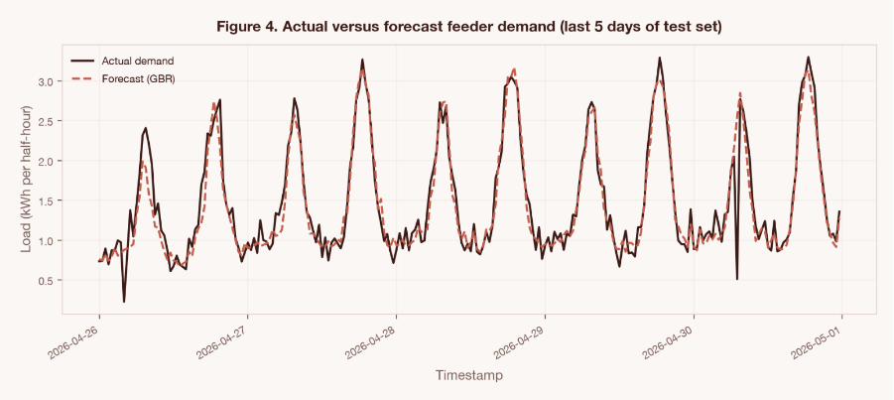Figure 4. Actual versus forecast feeder demand for the last five days of the test set.
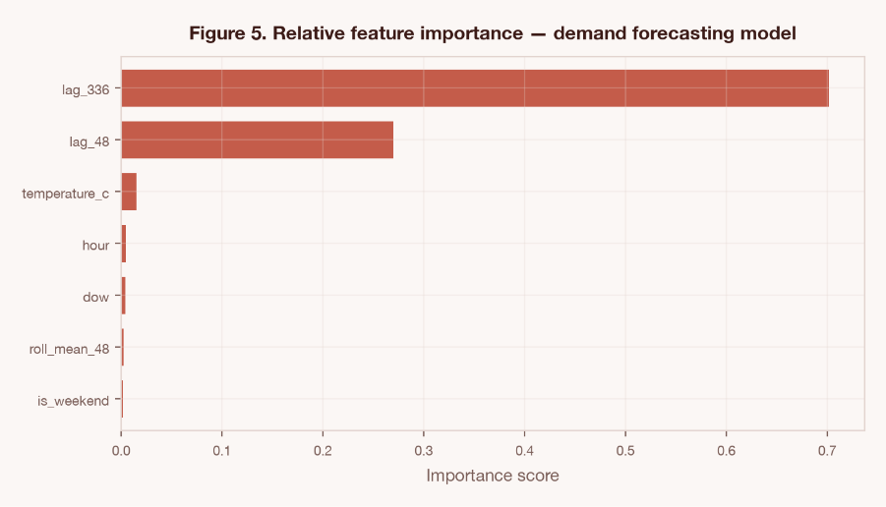Figure 5. Relative feature importance in the demand forecasting model, lagged demand and hour of day dominate, consistent with the daily periodicity described in Section 1.4.
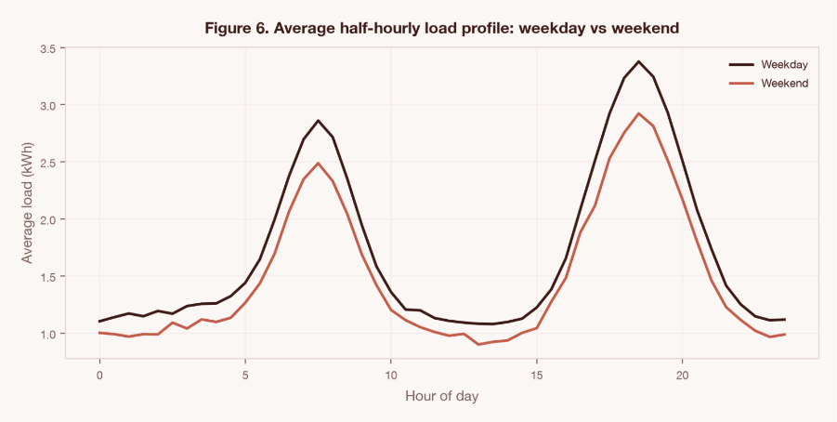Figure 6. Average half hourly load profile comparing weekday and weekend patterns, illustrating the seasonal and behavioural structure the model must capture.
4.5 Critical Evaluation of the Proof of Concept
This synthetic series of production is very smooth and mostly deterministic a different type of injected demand would perhaps be more noisy, show a more varied behaviour over thousands of feeders, lose readings, and also experience true event outliers in the event of extreme weather/conditions, not experienced here with this synthetic production deployment. The proof of concept would be read at that time as a validation of the pattern, Feature engineering (dimensions) on curated lake house tables, scheduled batch retraining of the model, publishing charts/metrics to the serving layer. The proof of concept is not designed to be interpreted as a proof of accuracy of the forecasted predictions but rather proof of the architectural pattern, feature engineering in curated tables in the lake house, batch retraining the model at a schedule, and publishing the charts/metrics to the serving layer. This component can be scaled by using per feeder or per segment models (or even a single model with a feeder identifier as categorical variable) and also by automatizing the retuning of the hyperparameters as consumption pattern changes (categorical as opposed to manually retaining it from time to time or when consumption pattern changes) and can also be combined with the orchestration layer described in 3 so that the retraining is triggered when the model is supposed to be retrained on a schedule, or when data drift is detected, rather than simply manually.

5. SUGGESTIONS FOR IMPROVEMENT, GOVERNANCE AND UPKEEP
5.1 Governance Maturity
The ownership of data should be formalised through the introduction of named data stewards per source domain (metering, EV charging, solar, billing, maintenance), and a data catalogue should be introduced to document data lineage, data quality rules and data sensitivity classification. The creation of a Data Protection Officer for such analytics use cases, already required by GDPR style processing of household consumption data (Frost & Sullivan, 2020), should coordinate privacy impact assessments for new use cases but should be especially efficient for dynamic pricing or demand response analytics, which work with personal data in volume. These obligations can be operationalised without the development of a new compliance software using practical governance tooling like the one described by Robin Data (2025) which consists of documented privacy and audit workflows, that can be templated.
5.2 Sustainability
Energy consumption for cloud and data centre applications is a material sustainability issue for an energy company and energy efficiency and workload aware resource management should be designed as a first class design goal for next generation cloud platform, not an afterthought, says Buyya et al. (2024), while Katal et al. (2023) examine techniques that lower energy consumption in the data centre while maintaining service levels such as workload consolidation, virtual machine right sizing, and dynamic scaling at the software level. MES should focus on regions and providers that have good indicators of their renewable energy commitment and their carbon intensity data published (matches cross cutting monitoring layer in Figure 3), schedule non urgent workloads in batches (historical reprocessing), for example when there is less carbon intensive, and monitor cost/carbon dashboards in parallel, thus evaluating architectural choices at the same time on both cost and carbon perspectives.
5.3 Ongoing Maintenance
Ingestion pipelines should be tested to schema and data quality contracts before being deployed, untested runbooks should be replaced with scheduled disaster recovery runs. A cadence of patching and dependency updates should be established for all parts of the pipeline. The service level objectives for pipeline latency and freshness should be on the observability dashboards mentioned in Section 3, before they affect billing accuracy or grid safety monitoring.
5.4 Innovation Roadmap
- Edge and fog computing for substation analytics, bringing anomaly detection closer to the sensor to minimize latency and bandwidth requirements on the central platform, especially with an increasing number of sensors (Bayındır et al., 2025).
- The data minimisation principle referred to in Section 1.7 is directly related to federated or privacy preserving learning schemes for household level forecasting models that can be used to improve the models without centralising raw personally identifiable consumption data.
- A digital twin of the distribution network using real time telemetry data and the curated historical data in the lake house to model the impact of new EV charging or solar deployment before deployment.
- Progressive migration of demand forecasting proof of concept in Section 4 to automated self retraining models that are integrated to the orchestration layer and customer facing pricing models are reviewed by human in the loop for any model that feeds into customer facing pricing decisions.
Collectively, these recommendations put MES on a path to move beyond the initial architecture migration to an ongoing, auditable and environmentally sustainable data platform.

CONCLUSION
Like many utilities today, MetroEnergy Solutions has a very real challenge that utilities face today, How to integrate disparate data, often very high speed, from operations with disparate legacy platforms and ever increasing regulatory demands. This report has proposed that the future doesn't need to be one proprietary platform, but rather a clear and defined architectural approach that is managed end to end with security, data governance and observability controls and is continually evaluated for cost and sustainability. This small analytics component can be extended to this architecture to provide believable short term demand forecasts as shown in the proof of concept in Section 4 and can be scaled and governed as proposed in Section 5 to include fault detection, predictive maintenance and demand response for MES's entire estate. For MES, the key takeaway from the central lesson is that it's not about any one vendor, it's about architectural discipline to create a resilient, compliant and cost controlled energy data ecosystem.

References
Bayındır, K.Ç. et al. (2025) 'Comprehensive review of edge computing for power systems, state of the art, architecture, and applications', Applied Sciences, 15(8), p.4592.
Buyya, R., Ilager, S. and Arroba, P. (2024) 'Energy-efficiency and sustainability in new generation cloud computing, a vision and directions for integrated management of data centre resources and workloads', Software, Practice and Experience, 54(1), pp.24–38.
Databricks (2026) Data lakes vs data warehouses, what your organization needs to know. Available at, https,//www.databricks.com/blog/data-lakes-vs-data-warehouses-what-your-organization-needs-know (Accessed, 4 July 2026).
Frost & Sullivan (2020) Impact of General Data Protection Regulation (GDPR) on smart meters and smart pumps. Available at, https,//www.frost.com/growth-opportunity-news/impact-of-general-data-protection-regulation-gdpr-on-smart-meters-and-smart-pumps/ (Accessed, 4 July 2026).
Gubbi, J., Buyya, R., Marusic, S. and Palaniswami, M. (2013) 'Internet of Things (IoT), a vision, architectural elements, and future directions', Future Generation Computer Systems, 29(7), pp.1645–1660.
IBM (2026) Data warehouses vs. data lakes vs. data lakehouses. Available at, https,//www.ibm.com/think/topics/data-warehouse-vs-data-lake-vs-data-lakehouse (Accessed, 4 July 2026).
Katal, A., Dahiya, S. and Choudhury, T. (2023) 'Energy efficiency in cloud computing data centers, a survey on software technologies', Cluster Computing, 26(3), pp.1845–1875.
Mell, P. and Grance, T. (2011) The NIST definition of cloud computing. NIST Special Publication 800-145. Gaithersburg, MD, National Institute of Standards and Technology.
Robin Data (2025) Data protection in the energy and environment sector. Available at, https,//www.robin-data.io/en/data-protection-and-data-security-academy/wiki/data-protection-in-energy-environmental-industry (Accessed, 4 July 2026).
Siano, P. (2014) 'Demand response and smart grids — a survey', Renewable and Sustainable Energy Reviews, 30, pp.461–478.

Appendix

# --- Setup: imports and output paths ---
# Dependencies: numpy, pandas, matplotlib, scikit-learn
# Optional (Excel cross-check only): openpyxl
import os
from pathlib import Path

import numpy as np
import pandas as pd
import matplotlib.pyplot as plt
from sklearn.ensemble import GradientBoostingRegressor
from sklearn.metrics import mean_absolute_error, mean_absolute_percentage_error, r2_score

# Notebook-friendly plotting (inline display + saved figures for the report)
%matplotlib inline
plt.rcParams.update({"font.size": 10, "figure.dpi": 150})

# Local output folders (equivalent to /home/poc and /home/figs in the script)
BASE_DIR = Path(".").resolve()
SUPPORT_DIR = BASE_DIR / "support"
OUTPUT_DIR = SUPPORT_DIR / "output"
FIGURES_DIR = OUTPUT_DIR / "figs"
METRICS_PATH = OUTPUT_DIR / "metrics.csv"
DATASET_PATH = BASE_DIR / "PoC Data_105602.xlsx"

os.makedirs(FIGURES_DIR, exist_ok=True)

RNG = np.random.default_rng(42)
print(f"Working directory: {BASE_DIR}")
print(f"Figures will be saved to: {FIGURES_DIR}")
print(f"Metrics will be saved to: {METRICS_PATH}")

1. Data acquisition
Simulated ingestion of half-hourly smart meter feed (120 days).
In [ ]:
# --------------------------------------------------------------------------------------
# 1. DATA ACQUISITION (simulated ingestion of half-hourly smart meter feed, 120 days)
# --------------------------------------------------------------------------------------
periods = 120 * 48 # 120 days of half-hourly readings
idx = pd.date_range("2026-01-01", periods=periods, freq="30min")
df = pd.DataFrame(index=idx)
df["hour"] = df.index.hour + df.index.minute / 60
df["dow"] = df.index.dayofweek
df["doy"] = df.index.dayofyear
df["is_weekend"] = (df["dow"] >= 5).astype(int)

# Ambient temperature feed (proxy for a third-party weather API ingested into the lake)
seasonal_temp = 8 + 6 * np.sin(2 * np.pi * (df["doy"] - 30) / 365)
df["temperature_c"] = seasonal_temp + RNG.normal(0, 1.5, periods)

# Daily demand shape: morning + evening peaks, damped on weekends, temperature-sensitive
morning_peak = 1.6 * np.exp(-((df["hour"] - 7.5) ** 2) / (2 * 1.2 ** 2))
evening_peak = 2.4 * np.exp(-((df["hour"] - 18.5) ** 2) / (2 * 1.6 ** 2))
overnight_base = 0.9 + 0.15 * np.sin(2 * np.pi * df["hour"] / 24)
weekend_damp = np.where(df["is_weekend"] == 1, 0.85, 1.0)
heating_load = np.clip(15 - df["temperature_c"], 0, None) * 0.05 # more load when colder

df["load_kwh"] = (
(overnight_base + morning_peak + evening_peak) * weekend_damp
+ heating_load
+ RNG.normal(0, 0.12, periods)
).clip(lower=0.05)

# Fault/anomaly injection: occasional voltage-related dropout, reflecting real feeder noise
fault_idx = RNG.choice(periods, size=6, replace=False)
df.iloc[fault_idx, df.columns.get_loc("load_kwh")] *= 0.2

print(f"Raw synthetic feed: {len(df):,} half-hourly rows")
print(f"Date range: {df.index.min()} → {df.index.max()}")
print(f"Injected fault indices (row positions): {sorted(fault_idx.tolist())}")
In [ ]:
# Quick inspection — useful for assessment and debugging
display(df.head())
display(df.describe().T)
print(f"Missing values:\n{df.isna().sum()}")

2. Feature engineering
Representative of curated "gold zone" transformation logic.
In [ ]:
# --------------------------------------------------------------------------------------
# 2. FEATURE ENGINEERING (representative of curated "gold zone" transformation logic)
# --------------------------------------------------------------------------------------
df["lag_48"] = df["load_kwh"].shift(48) # same time yesterday
df["lag_336"] = df["load_kwh"].shift(336) # same time last week
df["roll_mean_48"] = df["load_kwh"].rolling(48).mean()
df = df.dropna()

features = ["hour", "dow", "is_weekend", "temperature_c", "lag_48", "lag_336", "roll_mean_48"]
target = "load_kwh"

split = int(len(df) * 0.85)
train, test = df.iloc[:split], df.iloc[split:]

X_train, y_train = train[features], train[target]
X_test, y_test = test[features], test[target]

print(f"Feature matrix shape after lag/rolling dropna: {df.shape}")
print(f"Train rows: {len(train):,} | Test rows: {len(test):,}")
print(f"Features: {features}")
In [ ]:
# Optional cross-check against the bundled Excel dataset (PoC Data_105602.xlsx)
# Requires openpyxl: pip install openpyxl
if not DATASET_PATH.exists():
print(f"No reference file found at {DATASET_PATH.name} — skipping cross-check.")
else:
try:
reference = pd.read_excel(DATASET_PATH, sheet_name="synthetic_mes_smart_meter_data")
reference["timestamp"] = pd.to_datetime(reference["timestamp"])
reference = reference.set_index("timestamp")
match = np.allclose(df[features + [target]].values, reference[features + [target]].values)
print(f"Reference file: {DATASET_PATH.name}")
print(f"Generated data matches bundled Excel: {match}")
except ImportError:
print("openpyxl not installed — skip Excel cross-check (pip install openpyxl to enable).")

3. Model training
Batch job — would run on a scheduled compute cluster/serverless job.
In [ ]:
# --------------------------------------------------------------------------------------
# 3. MODEL TRAINING (batch job - would run on a scheduled compute cluster/serverless job)
# --------------------------------------------------------------------------------------
model = GradientBoostingRegressor(
n_estimators=250, max_depth=3, learning_rate=0.05, random_state=42
)
model.fit(X_train, y_train)
pred = model.predict(X_test)

mae = mean_absolute_error(y_test, pred)
mape = mean_absolute_percentage_error(y_test, pred) * 100
r2 = r2_score(y_test, pred)

print(f"MAE: {mae:.4f} kWh")
print(f"MAPE: {mape:.2f}%")
print(f"R2: {r2:.4f}")

metrics = pd.DataFrame(
{"Metric": ["MAE (kWh)", "MAPE (%)", "R-squared"], "Value": [round(mae, 3), round(mape, 2), round(r2, 3)]}
)
metrics.to_csv(METRICS_PATH, index=False)
display(metrics)

4. Visual evidence of implementation
Report figures are numbered sequentially by appearance in the Word technical report:
Report figure | Content
Figures 1–3 | Shared responsibility, MES architecture, end-to-end dataflow (architecture diagrams)
Figures 4–6 | Forecast vs actual, feature importance, weekday/weekend profile (this PoC)
The architecture diagrams (Figures 1–3) are generated by support/generate_mes_submission.py. The cells below regenerate Figures 4–6 for the PoC section.
Figures are displayed inline and saved to output/figs/ for report insertion.
In [ ]:
# Architecture diagrams (Figures 1–3) — generated via support/generate_mes_submission.py
import sys
sys.path.insert(0, str(SUPPORT_DIR))
from generate_mes_submission import (
fig1_shared_responsibility,
fig2_architecture,
fig3_dataflow,
)

fig1_shared_responsibility()
fig2_architecture()
fig3_dataflow()
print("Saved Figures 1–3 to", FIGURES_DIR)
In [ ]:
# Chart 1: last 5 days actual vs predicted
fig, ax = plt.subplots(figsize=(9, 4))
last = test.iloc[-240:]
last_pred = pred[-240:]
ax.plot(last.index, last[target], label="Actual demand", color="#3B1A16", linewidth=1.5)
ax.plot(last.index, last_pred, label="Forecast (GBR model)", color="#C45C4A", linewidth=1.5, linestyle="--")
ax.set_title("Figure 4. Actual versus forecast feeder demand (last 5 days of test set)")
ax.set_xlabel("Timestamp")
ax.set_ylabel("Load (kWh per half-hour)")
ax.legend()
ax.grid(alpha=0.3)
fig.autofmt_xdate()
fig.tight_layout()
fig.savefig(FIGURES_DIR / "fig4_forecast_vs_actual.png")
plt.show()
In [ ]:
# Chart 2: feature importance
importances = pd.Series(model.feature_importances_, index=features).sort_values()
fig, ax = plt.subplots(figsize=(7, 4))
importances.plot(kind="barh", ax=ax, color="#C45C4A")
ax.set_title("Figure 5. Relative feature importance — demand forecasting model")
ax.set_xlabel("Importance score")
fig.tight_layout()
fig.savefig(FIGURES_DIR / "fig5_feature_importance.png")
plt.show()
display(importances.to_frame("Importance"))
In [ ]:
# Chart 3: average daily load profile (weekday vs weekend) - seasonal pattern visualisation
profile = df.groupby(["is_weekend", "hour"])["load_kwh"].mean().unstack(level=0)
fig, ax = plt.subplots(figsize=(8, 4))
ax.plot(profile.index, profile[0], label="Weekday", color="#3B1A16")
ax.plot(profile.index, profile[1], label="Weekend", color="#C45C4A")
ax.set_title("Figure 6. Average half-hourly load profile: weekday vs weekend")
ax.set_xlabel("Hour of day")
ax.set_ylabel("Average load (kWh)")
ax.legend()
ax.grid(alpha=0.3)
fig.tight_layout()
fig.savefig(FIGURES_DIR / "fig6_daily_profile.png")
plt.show()
In [ ]:
print("Charts and metrics generated successfully.")
print(f"Saved metrics: {METRICS_PATH}")
print("Saved figures:")
for name in ["fig4_forecast_vs_actual.png", "fig5_feature_importance.png", "fig6_daily_profile.png"]:
print(f" - {FIGURES_DIR / name}")

